TC03

Test Scenario : ESS User Login

Test Case Title : Verify login with Invalid ESS Username and Valid Password

Test Case Steps : 1) Launch bowser

2) Open URL "https://opensource-demo.orangehrmlive.com/web"

3) Enter Invalid Username and Valid Password

4) Click on Login Button

5) Document all the results you received

**Let’s add Invalid User ESS and Valid Password as below :**

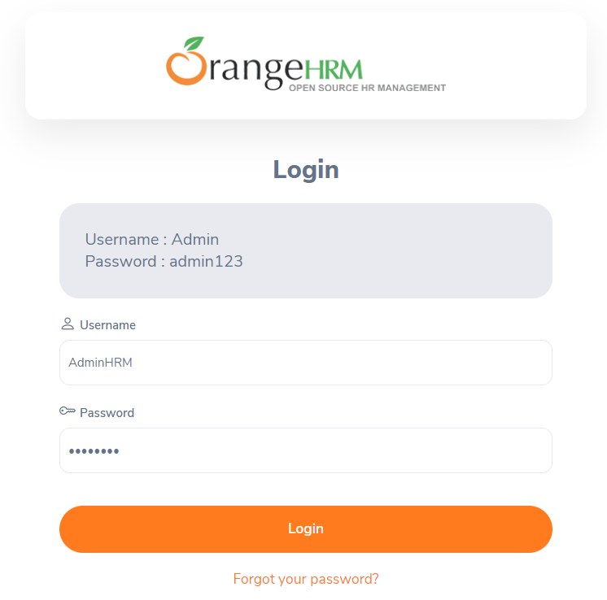

**Now click on Login Button :**

